Name________

Semester 2 Quiz 2
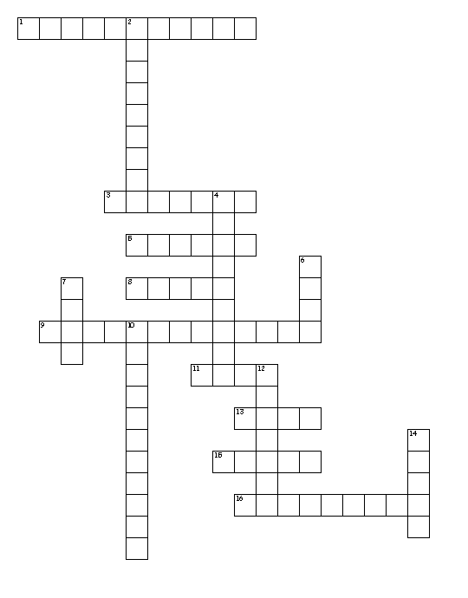

Word Bank
Hyper Trans Hyperbole Hyperactive Brev Brevity
Brief Translate Transfusion Medi Median Mediterranean Mediate Noun Verb Adjective

Across
1. exaggerated activity
3. intervene between people in a dispute in order to bring about an agreement or reconciliation
5. the middle value of a range of numbers
8. across
9. a sea in the middle of two continents
11. What part of speech is translated in the following sentence? The young girl translated the conversation for her foreign grandmother.
13. middle
15. lasting only a short period
16. an extreme exaggeration
Down
2. what part of speech is the word hyperactivity in the following sentence? The hyperactive student gave an excellent rendition at the poetry battle
4. express the sense of another language
6. What part of speech is transfusion in the following sentence? After the car accident, the driver needed a transfusion.
7. short
10. the act of transferring donated blood
12. the use of concise/ exact words
14. over

Hyper over
Trans across
Hyperbole an extreme exaggeration
Hyperactive exaggerated activity
Brev short
Brevity the use of concise/ exact words
Brief lasting only a short period
Translate express the sense of another language
Transfusion the act of transferring donated blood
Medi middle
Median the middle value of a range of numbers
Mediterranean a sea in the middle of two continents
Mediate intervene between people in a dispute in order to bring about an agreement or reconciliation
Noun What part of speech is transfusion in the following sentence? After the car accident, the driver needed a transfusion.
Verb What part of speech is translated in the following sentence? The young girl translated the conversation for her foreign grandmother.
Adjective what part of speech is the word hyperactivity in the following sentence? The hyperactive student gave an excellent rendition at the poetry battle

