Name________________

Semester 2 Quiz 1
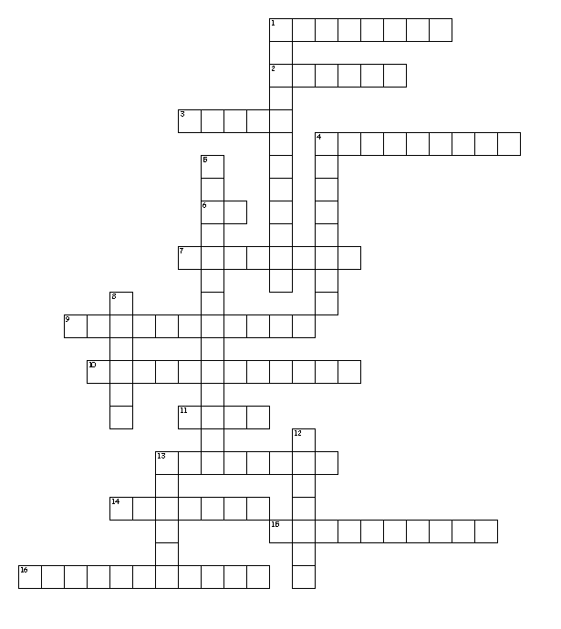

Word Bank (No spaces between two word answers)
Tort contra alter se
Contort retort altruism altercation
Alter ego contradict contrary secede
Secluded pronoun preposition adjective
Concrete noun abstract noun Possessive noun

Across
1. concern and caring for OTHERS
2. to break away (usually refers to a country) or replace
3. change
4. describes a noun or a pronoun
6. apart
7. kept apart or private
9. expressing a relation/position to another word or element in the phrase
10. a person, place, or thing you can touch
11. twist
13. opposite in nature, direction, or meaning
14. Twist or bend out of normal shape
15. Deny the truth, especially by asserting the opposite
16. a noisy argument or disagreement, especially in public

Down
1. an idea you can NOT touch
4. other personality
5. a person, place, thing, or idea that shows ownership
8. to say something or respond in a sharp, disrespectful way
12. takes the place of a noun or another pronoun
13. against

Tort twist
Alter change
Contra against
Se apart
Alterego other personality
Altruism concern and caring for OTHERS
Contradict Deny the truth, especially by asserting the opposite
Contrary opposite in nature, direction, or meaning
Secluded kept apart or private
Secede to break away (usually refers to a country) or replace
Contort Twist or bend out of normal shape
Retort to say something or respond in a sharp, disrespectful way
Altercation a noisy argument or disagreement, especially in public
Adjective describes a noun or a pronoun
Pronoun takes the place of a noun or another pronoun
Concretenoun a person, place, or thing you can touch
Abstractnoun an idea you can NOT touch
Possessivenoun a person, place, thing, or idea that shows ownership
Preposition expressing a relation/position to another word or element in the phrase

