Name______________________________

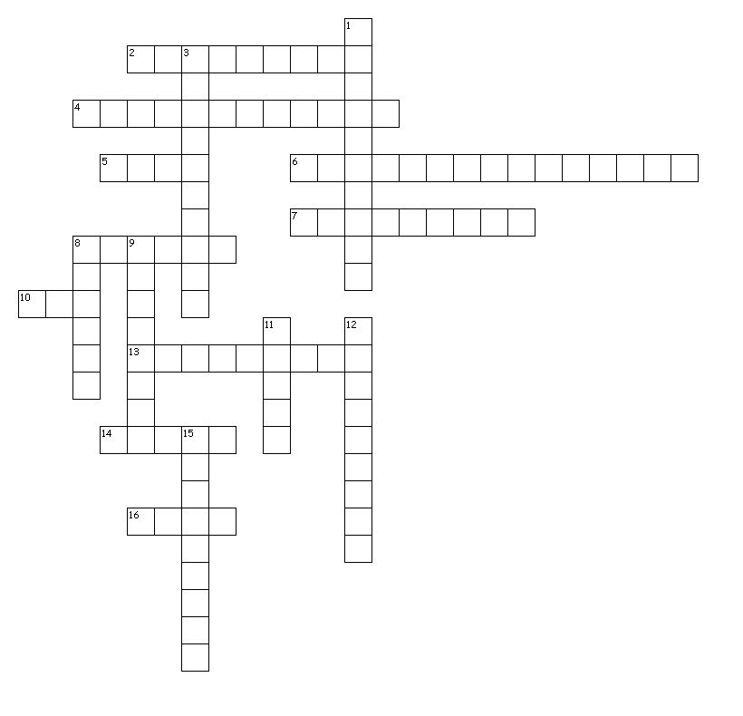

Word Bank:
Polis Agog Demo Urb
Democracy Demography Pedagogue Demagogue
Urban Suburb Metropolis Acropolis
Simile Metaphor Alliteration personification
Hyperbole

Across
2. Leader who carries the people
4. Alice’s aunt ate apples and acorns around August.
5. people
6. The empty house shuddered with sadness
7. It was so cold I saw polar bears wearing jackets.
8. The shells were as shiny as a piece of copper
10. city
13. teacher or leader of children
14. relating to a city
16. leader
Down
1. study of changing human populations
3. very large and densely populated city
8. Residential area separate from a city but belonging to a city
9. The bees were bullets that stung
11. city
12. system of government elected by the people for the people
15. fortified part of an Ancient Greek city, Athens. Built on a hill

Polis city
Agog leader
Demo people
Urb city
Democracy system of government elected by the people for the people
Demography study of changing human populations
Pedagogue teacher or leader of children
Demagogue Leader who carries the people
Urban relating to a city
Suburb Residential area separate from a city but belonging to a city
Metropolis very large and densely populated city
Acropolis fortified part of an Ancient Greek city, Athens. Built on a hill
Simile The shells were as shiny as a piece of copper
Metaphor The bees were bullets that stung
Alliteration Alice’s aunt ate apples and acorns around August.
personification The empty house shuddered with sadness
Hyperbole It was so cold I saw polar bears wearing jackets.

