Name______________________________

Quarter 4 Set 3: Luc, Rupt, Trib, Thermo
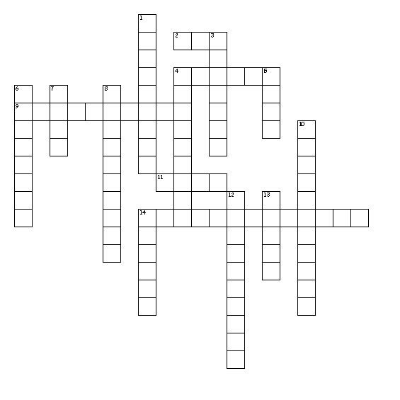

Word bank-Answer with two words have no space between
Luc Translucent Lucid Rupt Corrupt
Abrupt Trib Contribute Attribute Thermos
Thermostat Thermonuclear North Korea students adjective
Verb Noun

Across
2. light
4. sudden and unexpected
9. a device that automatically regulates temperature/heat
11. break
14. elating to or using nuclear reactions that occur at only high temperatures

Down
1. What part of speech is Translucent in the following sentence. It almost appeared as though I could see through the translucent scales of the unusual fish.
3. having or showing a willingness to act dishonestly
4. a characteristic of someone
5. pay
6. What is NOT an example of something that is corrupt? Government, criminals, students
7. What part of speech is contribute in the following sentence? I want someone who can contribute intelligent conversation, not grovel at my feet.
8. help a cause or a group
10. allowing light but not detailed images
12. What country is most like to use a thermonuclear device? North Korea, Switzerland, France
13. expressed clearly
14. heat

Luc light
Translucent allowing light but not detailed images
Lucid expressed clearly
Rupt break
Corrupt having or showing a willingness to act dishonestly
Abrupt sudden and unexpected
Trib pay
Contribute help a cause or a group
Attribute a characteristic of someone
Thermo heat
Thermostat a device that automatically regulates tem/heat
Thermonuclear elating to or using nuclear reactions that occur at only high temperatures
northKorea What country is most like to use a thermonuclear device? North Korea, Switzerland, France
students What is NOT an example of something that is corrupt? Government, criminals, students
adjective What part of speech is Translucent in the following sentence. It almost appeared as though I could see through the translucent scales of the unusual fish.
Verb What part of speech is contribute in the following sentence? I want someone who can contribute intelligent conversation, not grovel at my feet.

