Name________________________________________________

Quarter 4 Set 2

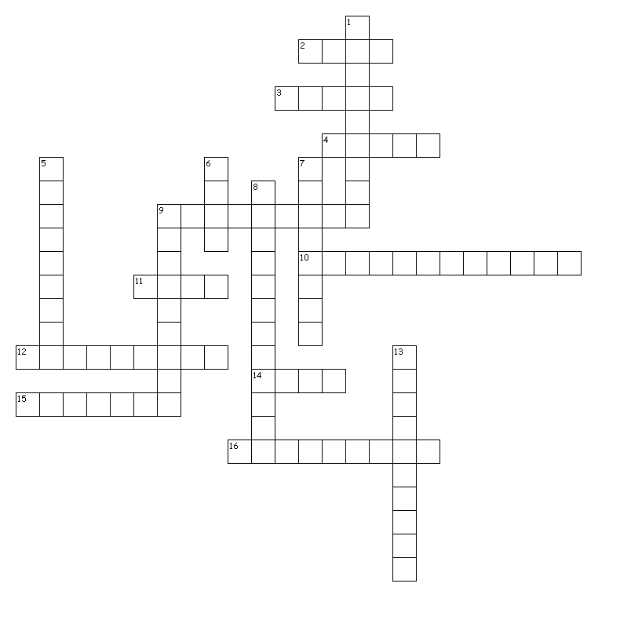

Word Bank-Two-word answers have no space between them
Grat Gratitude Ingrate Sanct Sanctified
Sanctuary Anim Animosity Animated Sens
Sensation Insensate Bully Concrete noun Adjective
Noun Abstract noun

Across
2. pleasing
3. holy
4. Who would be seen as someone who is insensate: nurse, teacher, coach, bully?
9. strong hatred
10. What part of speech is the underline word in the following sentence? The gratitude the teacher received from her students made her cry.
11. feel
12. a physical feeling or perception
14. What part of speech is the underline word in the following sentence? She had the strange sensation that someone was watching her.
15. an ungrateful person
16. lacking sympathy
Down
1. a place of refuge or safety
5. the quality of being thankful
6. mind
7. full of life
8. What part of speech is the underline word in the following sentence? The house was a sanctuary for runaway teens.
9. What part of speech is the underline word in the following sentence? After dinner, the discussion got more animated.
13. to make holy

Grat pleasing
Gratitude the quality of being thankful
Ingrate an ungrateful person
Sanct holy
Sanctified to make holy
Sanctuary a place of refuge or safety
Anim mind
Animosity strong hatred
Animated full of life
Sens feel
Sensation a physical feeling or perception
Insensate lacking sympathy
Bully Who would be seen as someone who is insensate: nurse, teacher, coach, bully?
Concretenoun What part of speech is the underline word in the following sentence? The house was a sanctuary for runaway teens.
Adjective What part of speech is the underline word in the following sentence? After dinner, the discussion got more animated.
Noun What part of speech is the underline word in the following sentence? She had the strange sensation that someone was watching her.
Abstractnoun What part of speech is the underline word in the following sentence? The gratitude the teacher received from her students made her cry.

