Quarter 2 Quiz 3
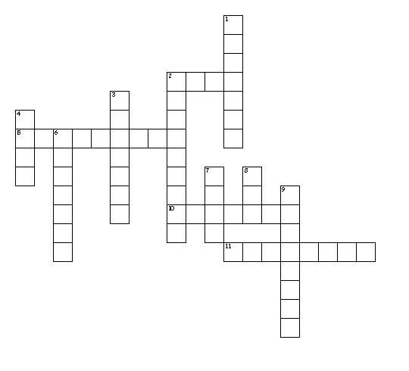
Word Bank
Ism
Pacifism
Activism
Dyna
Dynasty
Dynamic
Dign
Dignify
Indignant
Fort
Fortify
Fortitude

Across
2. strong
5. feeling or showing anger because you believe to be treated unfairly
10. constant change, activity, progress
11. belief of settling conflicts peacefully

Down
1. to make strong
2. strength of mind
3. sequence of rulers from the same family
4. worthy
6. to make something seem worthy or impressive
7. power
8. doctrine
9. the belief in supporting an issue

Ism doctrine
Pacifism belief of settling conflicts peacefully
Activism the belief in supporting an issue
Dyna power
Dynasty sequence of rulers from the same family
Dynamic constant change, activity, progress
Dign worthy
Dignify to make something seem worthy or impressive
Indignant feeling or showing anger because you believe to be treated unfairly
Fort strong
Fortify to make strong
Fortitude strength of mind

