Name_________________

Quarter 2 Quiz 2
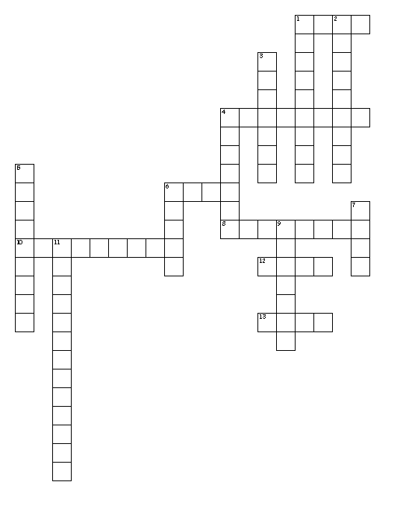
Across
1. cry out
4. person responsible or to blame for a crime
6. know
8. deserving blame
10. hiding your identity so you are not known
12. is a person, place, thing, or idea
13. blame
Down
1. making loud and confused noises
2. The novel was difficult to understand because it wasn’t written in chronological order In the sentence, chronological is what part of speech?
3. To cry out suddenly out of anger, pain, or excitement
4. existing for a long time
5. having knowledge or being aware of
6. time
7. “I don’t understand the material!” the student exclaimed. What part of speech is exclaimed?
9. takes place of a noun or an other pronoun
11. time order

Word Bank
Noun X 2 pronoun verb adjective
Chron culp clam cogn
Chronological chronic clamorous exclaim
Culpable culprit cognizant incognito

