Quarter 2 Quiz 1
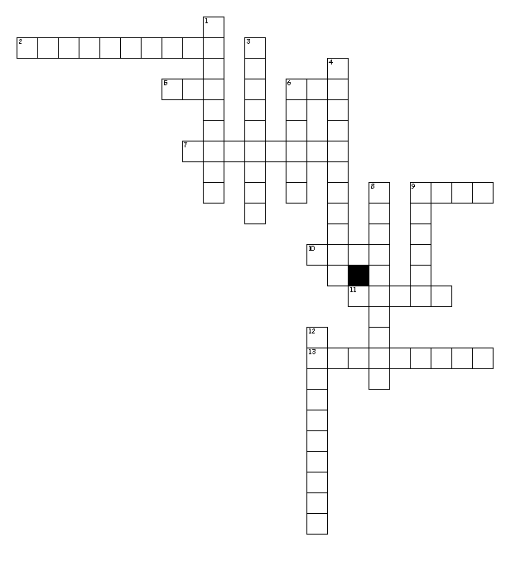

Word Bank
Pugn acr greg pac
Pugnacious repugnant segregate congregate
Gregarious egregious pacify pacifism
Acrimonious acrid Gandhi

Across
2. come together
5. sharp
6. peace
7. the beliefs in peace
9. group
10. fight
11. sharp taste or smell
13. offensive or an antagonist
Down
1. to separate or set apart from others
3. to make fun of another student in a bad way
4. a "burn" or "roast"
6. to bring peace
8. eager to fight
9. an example of a pacifist
12. social fond of company

