Quarter 1 Quiz 3
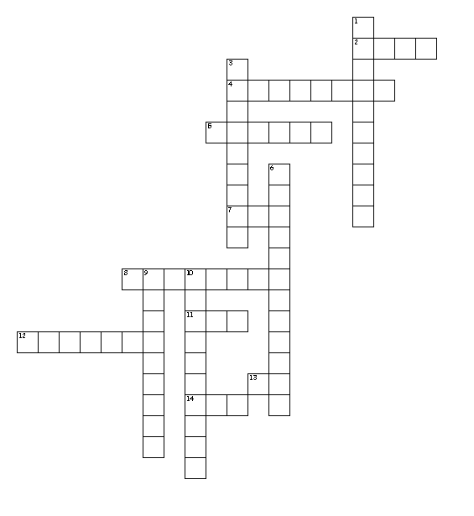
Word Bank
Voc il leg rid derision
Noun adjective illegible legible ridicule
Vociferously legend illiterate invocation

Across
2. King Arthur is a legend. What part of speech is legend?
4. the feeling that people express when they criticize and laugh at someone or something in an insulting way
5. King Arthur, Robin Hood
7. voice
8. to make fun of
11. read
12. type or print
13. not
14. laugh
Down
1. Prayers, Sacrifices, Chants
3. The seventh grader’s handwriting was illegible. What part of speech is illegible?
6. expressing feelings or opinions in a very loud or forceful way
9. not able to read
10. unable to read or write

