Name____________

Quarter 1 Quiz 1
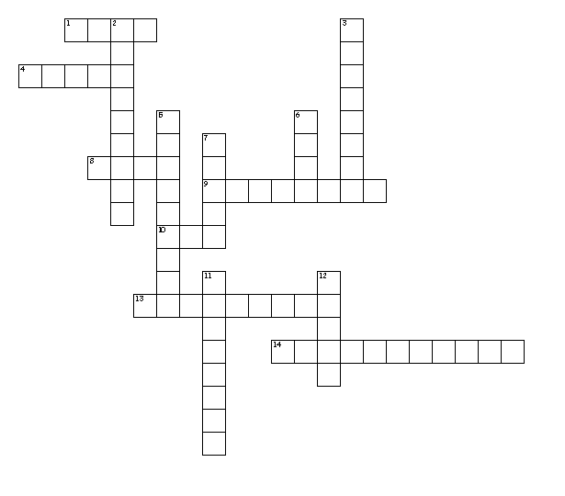
Word Bank
Vita scope meter cle noun
Vital telescope thermometer molecule true
Vitality periscope odometer minuscule false

Across
1. life
4. necessary or important
8. What part of speech is odometer?
9. The ________ often gets confused with a speedometer.
10. small
13. An instrument on a submarine to help see above water
14. measures heat
Down
2. instrument that helps far images appear closer
3. smallest particle
5. very small
6. TRUE or FALSE: Vital is an adjective in the following sentence. The heart is a vital organ.
7. look
11. strength and active
12. measure

