Name___________________________
Quarter 1 Quiz 2
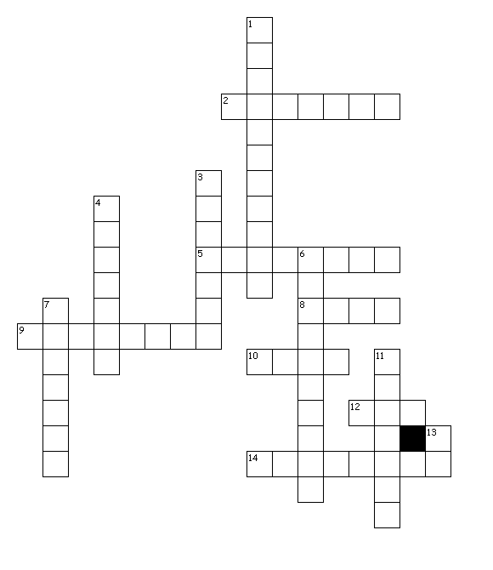
Word Bank
Tact tang man fy
Tactile manually maneuvering intangible fortify solidify clarify
Rectify tangible tactful

Across
2. to make correct
5. perceived by touch
8. touch
9. operated by hands
10. touch
12. hand
14. to make spoiled or hard
Down
1. move skillfully or carefully
3. make strong
4. having sensitivity when dealing with others
6. not able to be touched
7. connected with touch
11. to make clear
13. to make

